DIS-AM,C-Taino-Celt-12 5-8 in

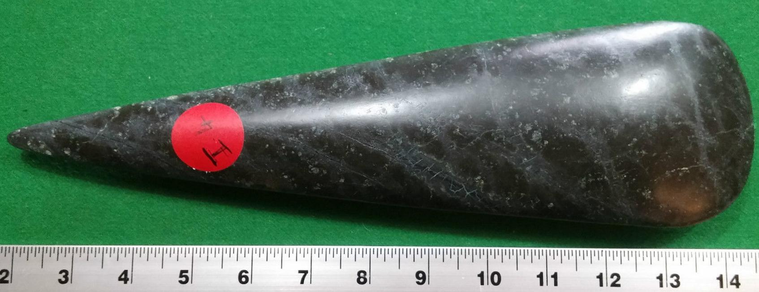

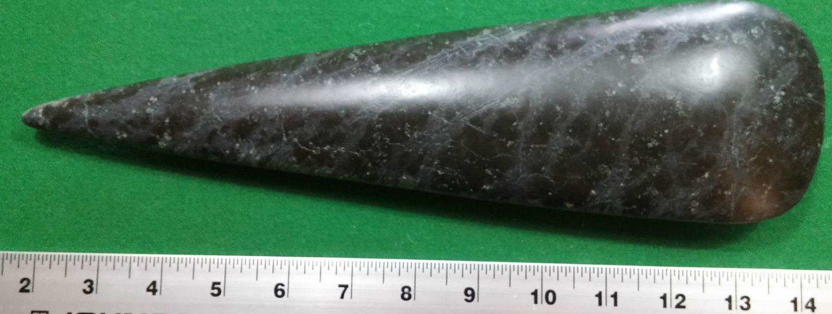

Sold by [user1billion](http://myworld.ebay.com/user1billion) ( [826](http://feedback.ebay.com/ws/eBayISAPI.dll?ViewFeedback&userid=user1billion) )

### Delivery package 1 of 1

Estimated delivery Friday, Mar 25, 2016 - Monday, Apr 4, 2016

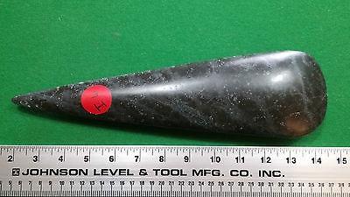

#### [Taino Ceremonial Stone Axe](http://www.ebay.com/itm/272146622429)

|  |  |
| --- | --- |
| Item price | $149.00 |
| Quantity | 1 |
| Item number | 272146622429 |
| Shipping service | Standard Int'l Shipping |

## Sales order

Sold by [highrating_lowpr...](http://myworld.ebay.com/highrating_lowprice) ( [16439](http://feedback.ebay.com/ws/eBayISAPI.dll?ViewFeedback&userid=highrating_lowprice) )

### Delivery package 1 of 1

Estimated delivery Monday, Mar 21, 2016

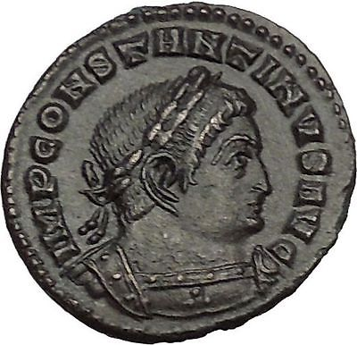

#### [Constantine I the Great Authentic Ancient Roman Coin Sol Sun God Cult i53326](http://www.ebay.com/itm/231791847384)

|  |  |
| --- | --- |
| Item price | $185.00 |
| Quantity | 1 |
| Item number | 231791847384 |
| Shipping service | Standard Shipping |

## Shipping address

Ralph J Coffman Jr

149 Atlantic Ave

Swampscott MA 01907-2427

United States

## Order total

|  |  |
| --- | --- |
| Subtotal | $334.00 |
| Shipping | $24.45 |

**Total**

$358.45

Order placed onTuesday, Mar 15, 2016 Payment methodPayPal Payment dateTuesday, Mar 15, 2016